**PRODUCT BACKLOG REFINEMENT-SPRINT 1**



**Date:24/02/2017**

Contents

I. BACKLOG ESTIMATE EVIDENCES 3

1. REGISTER NEW ACCOUNT 3

2. VISITOR LOG IN WITH EMAIL 4

3. VINASWAP MEMBER LOG OUT 4

4. VISITOR VIEW SITE MAINPAGE 5

5. LOGIN WITH FACEBOOK 5

6. SEARCHING INFO 6

7. REQUEST SWAP 6

8. EXCHANGE SWAP DETAIL 7

9. CREATE PROFILE 7

10. VIEW HEAD BANNER 7

11. EDIT HEAD BANNER 7

12. FEEDBACK 8

# BACKLOG ESTIMATE EVIDENCES

## REGISTER NEW ACCOUNT

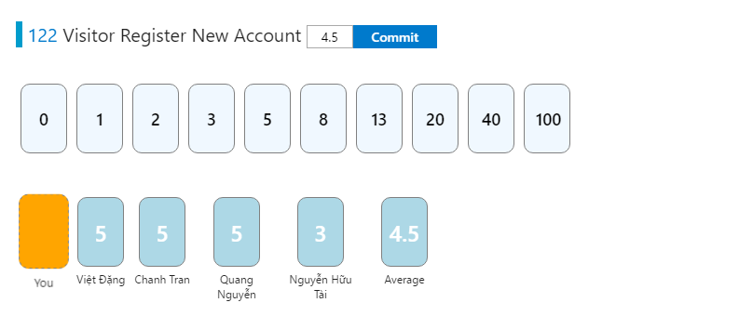

## VISITOR LOG IN WITH EMAIL

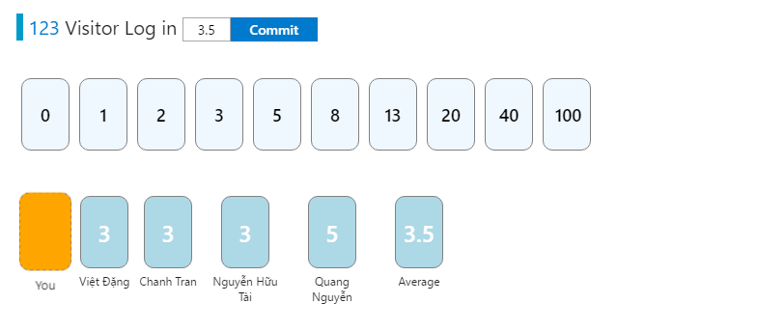

## VINASWAP MEMBER LOG OUT

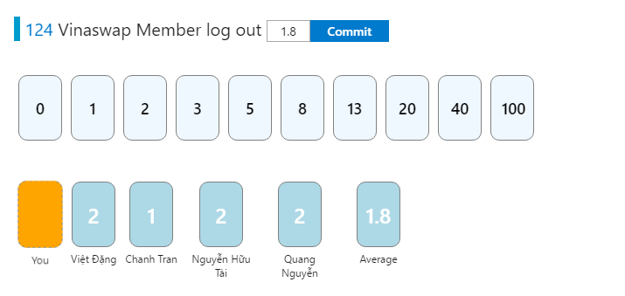

## VISITOR VIEW SITE MAINPAGE

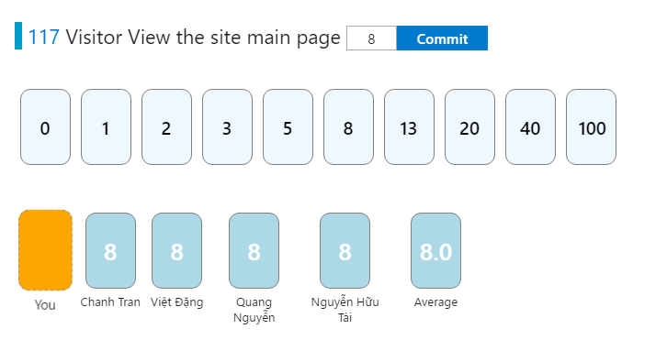

## LOGIN WITH FACEBOOK

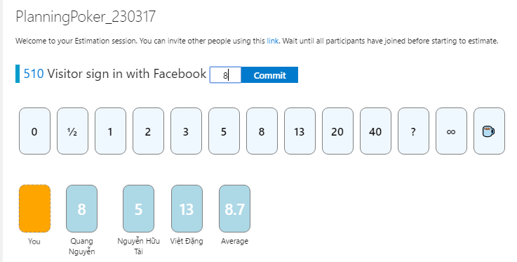

## SEARCHING INFO

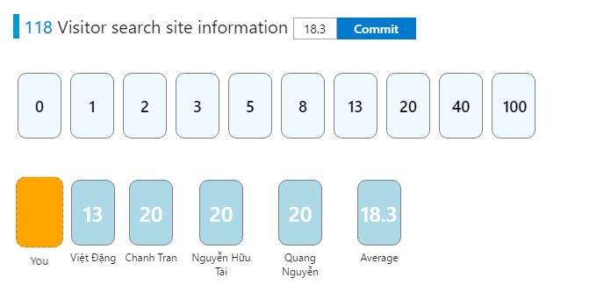

## REQUEST SWAP

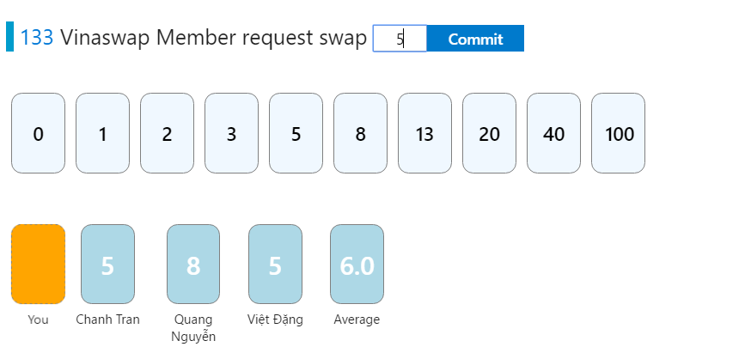

## EXCHANGE SWAP DETAIL

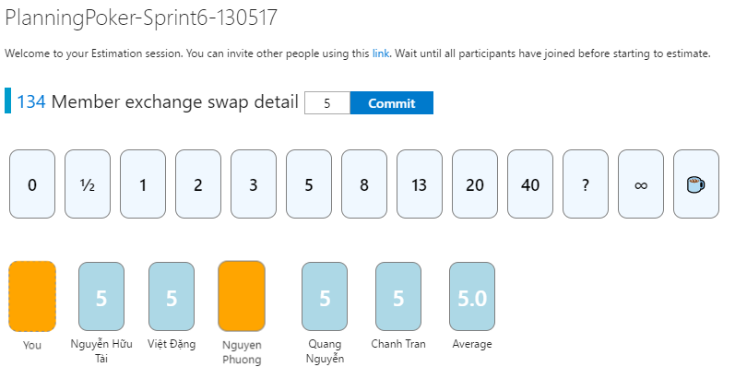

## CREATE PROFILE

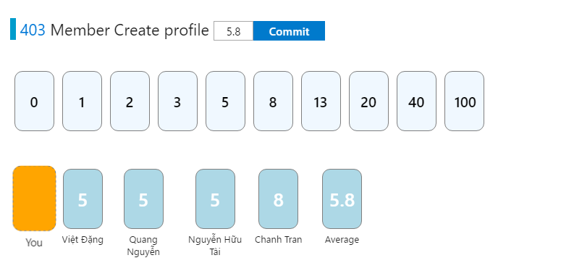

## VIEW HEAD BANNER



## EDIT HEAD BANNER



## FEEDBACK

